**Create Database:-**

mysql>create database health;

mysql>use health;

**Create tables:-**

mysql>create table doctor(d_ssn varchar(10) primary key,name varchar(20) not null,speciality varchar(20),experience varchar(10));

Query OK, 0 rows affected (0.33 sec)

mysql> desc doctor;

+------------+-------------+------+-----+---------+-------+

| Field | Type | Null | Key | Default | Extra |

+------------+-------------+------+-----+---------+-------+

| ssn | varchar(10) | NO | PRI | NULL | |

| name | varchar(20) | NO | | NULL | |

| speciality | varchar(20) | YES | | NULL | |

| experience | varchar(10) | YES | | NULL | |

+------------+-------------+------+-----+---------+-------+

mysql>create table patient(p_ssn varchar(20) primary key ,name varchar(20) not null,address varchar(30),age int);

Query OK, 0 rows affected (0.22 sec)

mysql>create table pharama_company(pc_name varchar(20) primary key,address varchar(20),phone_no bigint(10));

mysql> create table drug(trade_name varchar(20) primary key,formula varchar(20),pc_name varchar(10),foreign key(pc_name) references pharama_company(pc_name));

mysql>create table pharmacy(p_name varchar(20) primary key,address varchar(20),ph_no bigint(10));

mysql> create table checks(d_ssn varchar(10),p_ssn varchar(10),foreign key(d_ssn) references doctor(d_ssn),foreign key(p_ssn) references patient(p_ssn),primary key(d_ssn,p_ssn));

mysql>create table prescribe(d_ssn varchar(10),p_ssn varchar(10),trade_name varchar(20),prescribe_date date,quantity int(5),foreign key(d_ssn) references doctor(d_ssn),foreign key(p_ssn) references patient(p_ssn),foreign key(trade_name) references drug(trade_name),primary key(d_ssn,p_ssn,trade_name));

mysql> create table sold_by(trade_name varchar(20),p_name varchar(20),price int(8),foreign key(trade_name) references drug(trade_name),foreign key(p_name) references pharmacy(p_name),primary key(trade_name,p_name));

mysql> create table contract(pc_name varchar(20),p_name varchar(20),s_date date,end_date date,text varchar(30),supervisor varchar(20),foreign key(pc_name) references pharama_company(pc_name),foreign key(p_name) references pharmacy(p_name),primary key(pc_name,p_name));

**Insert Value:-**

Patient:-

sql> insert into patient values("P001","Gaurav","BGP",20);

Query OK, 1 row affected (0.009 sec)

sql> insert into patient values("P002","Sonu","Patna",65),("P003","Divesh","UP",80),("P004","Ram","Delhi",40),("P005","Ravi","Mumbai",35);

Query OK, 4 rows affected (0.011 sec)

Records: 4 Duplicates: 0 Warnings: 0

PHARAMA COMPANY:-

sql> insert into pharama_company values("nandi","Delhi",7867656568),("cipla","Mumbai",9967656568),("zinc","Goa",7879876545),("lupin","Up",9643434242),("mankind","chennai",7876845354);

Query OK, 5 rows affected (0.009 sec)

Records: 5 Duplicates: 0 Warnings: 0

sql> insert into pharama_company values("apollo","chennai",9844050879),("biocon","andhra",9877654678),("medplus","karnataka",8073805341);

Query OK, 3 rows affected (0.009 sec)

Records: 3 Duplicates: 0 Warnings: 0

Drug:-

sql> insert into drug values("Nice","CH2M1","Nandi");

Query OK, 1 row affected (0.009 sec)

sql> insert into drug values("sumo","N12MG2","cipla"),("Paracetomol","CH3","cipla"),("zincovit","xyz","zinc"),("sinarest","N12MG15","nandi");

Query OK, 4 rows affected (0.009 sec)

Records: 4 Duplicates: 0 Warnings: 0

DOCTOR:-

sql> insert into doctor values("D001","Durgesh","Cardilogists","5+");

Query OK, 1 row affected (0.010 sec)

sql> insert into doctor values("D002","Prince","Physicians","3+"),("D003","Aman","gastroenterologists","8+"),("D004","Amit","Nerologists","7+");

Query OK, 3 rows affected (0.009 sec)

Records: 3 Duplicates: 0 Warnings: 0

PHARMACY:-

sql> insert into pharmacy values("walgreens","bangalore",9823412345),("omnicare","tumkur",7890654678),("riteaid","shivmogga",8076812345),("healthmart","tiptur",8550885540),("bartell","chennai",8097065432);

CHECKS:-

sql> insert into checks values("D001","P001"),("D002","P002"),("D003","P003"),("D004","P004");

CONTRACT:-

sql> insert into contract values("biocon","healthmart",'1999/10/4','2021/6/7',"uuu","anup");

Query OK, 1 row affected (0.009 sec)

sql> insert into contract values("cipla","omnicare",'1999/9/20','2023/6/1',"hhh","sagar");

Query OK, 1 row affected (0.009 sec)

sql> insert into contract values("lupin","riteaid",'1997/11/11','2029/4/29',"vvv","kumar");

Query OK, 1 row affected (0.009 sec)

sql> insert into contract values("medplus","walgreens",'1982/9/7','2025/11/20',"nnn","nirup");

Query OK, 1 row affected (0.009 sec)

PRESCRIBE:-

sql> insert into prescribe values("D001","P001","Nice",'2021/5/29',3);

Query OK, 1 row affected (0.008 sec)

sql>insert into prescribe values("D002","P002","Paracetomol",'2021/9/20',10),("D003","P003","sinarest",'2021/4/8',30),("D004","P004","sumo",'2020/9/20',40),("D005","P005","zincovit",'2020/10/4',50);

Query OK, 4 rows affected (0.010 sec)

Records: 4 Duplicates: 0 Warnings: 0

SOLD_BY:-

sql> insert into sold_by values("Nice","bartell",30000);

Query OK, 1 row affected (0.011 sec)

sql> insert into sold_by values("Paracetomol","healthmart",20000),("sinarest","omnicare",12000),("sumo","riteaid",9000),("zincovit","walgreens",45000);

Query OK, 4 rows affected (0.009 sec)

Records: 4 Duplicates: 0 Warnings: 0

**Question and Answer:-**

1.List the details of patients who are 40 year old and have been checkes by Nerologists speecialist.

sql> select p.* from patient p ,doctor d,checks c where p.p_ssn=c.p_ssn and d.d_ssn=c.d_ssn and p.age=40 and d.speciality="Nerologists";

2.List the details of doctors who have given the prescription to more then 2 patients in year 2013.

sql> select D.*,count(P.D_ssn) from Doctor D,Prescribe P where D.D_ssn=P.D_ssn and year(P.prescribe_date)="2013" group by P.D_ssn having count(P.D_ssn)>=2;

3. 3.Retrieve the details of doctor having maximimum experience.

sql> select *from doctor where experience in (select max(experience)from doctor);

4.List the details of pharmaceutical companies who supply drug to more then 10 pharmacies in the same city where company is located.

sql>select distinct d.* from drug d,pharmacy p,sold_by s where p.p_name=s.p_name and s.trade_name=d.trade_name;

5.List the details of drug supplied by only one pharmaceutical company.

MariaDB [health]> select d.*,count(pc_name) from drug d group by pc_name having count(pc_name);

6.List the details of drug supplied.

sql> select p.*,d.trade_name from pharmacy p,sold_by s,drug d where s.p_name=p.p_name and d.trade_name=s.trade_name;

**Question and Answer Screenshot:-**

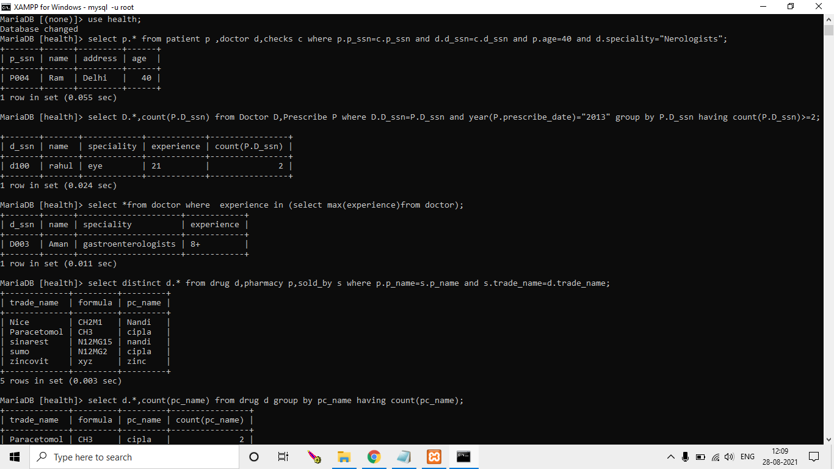

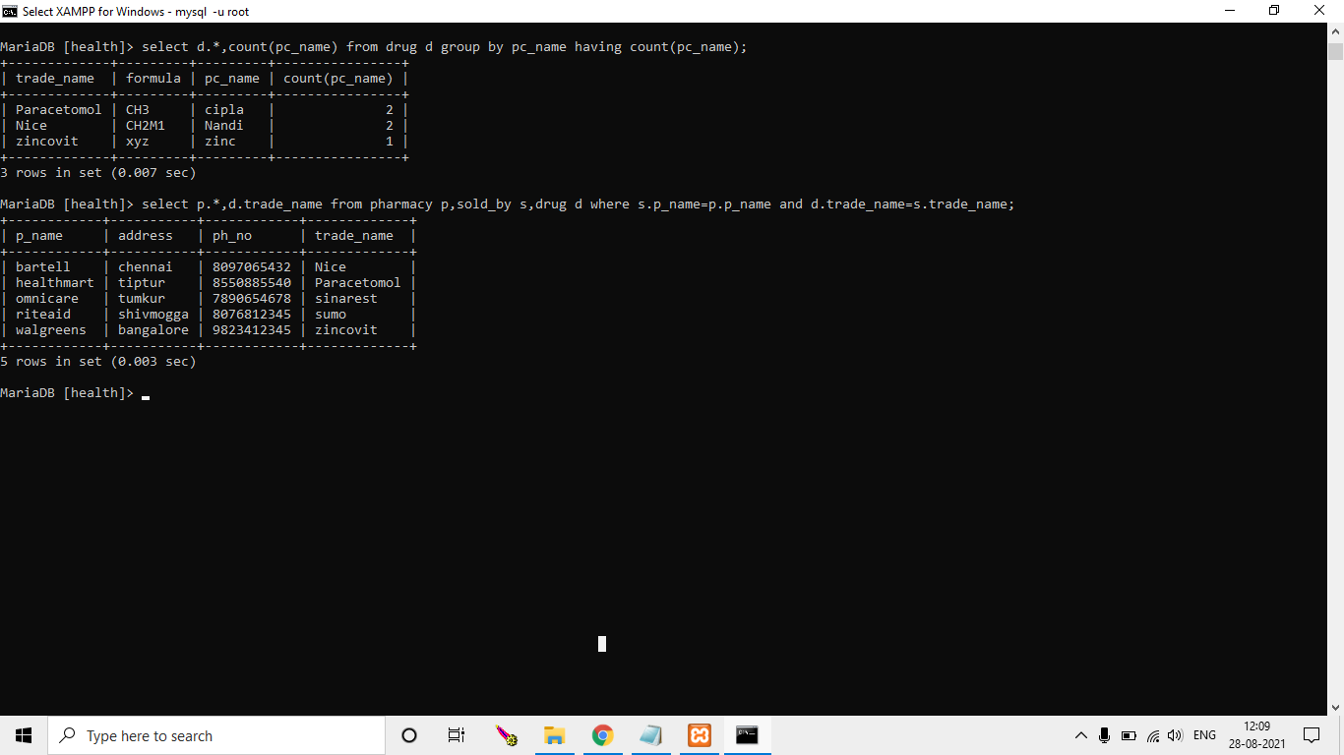

**Screenshot:-**